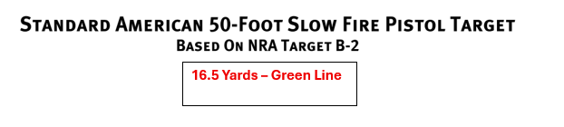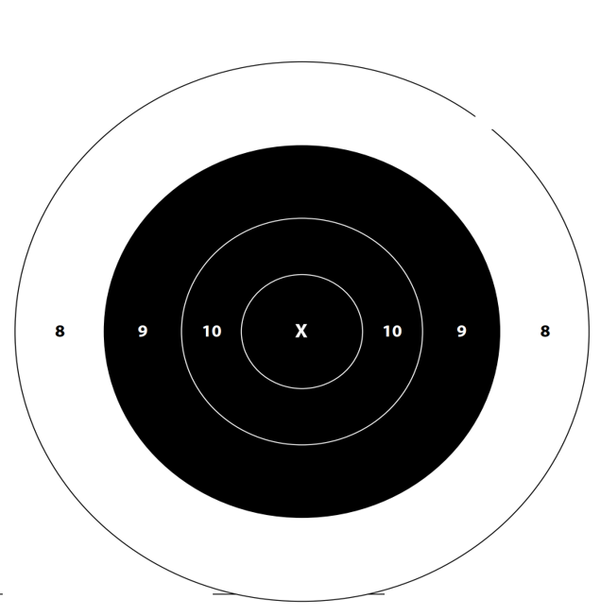p
ACCURACY PISTOL LEAGUE TARGET TWO (2) Full Name: _____________________________
Pistol 45+ Week Match #: _______ Target String #: ___________

